# Lab Summary: Get Started with Vertex AI Studio

## Lab Info

Title: Get Started with Vertex AI Studio  
Learning Path: Advanced: Generative AI for Developers  
Platform: Google Cloud Skills Boost  
Duration: ~1 hour

## Lab Objectives

- Learn how to transform an idea into a working generative AI application using Vertex AI Studio.  
- Practice prompt engineering to improve model outputs.  
- Use Gemini models to process both text and image inputs.  
- Adjust model parameters like temperature to refine responses.  
- Explore media generation tools to create images, audio, and video from prompts.

## Lab Content (Detailed)

### Task 1 – Create applications from prompts

We began by transforming a basic idea into a functional application using Vertex AI Studio.  
The goal was to assist an insurance analyst by summarizing client information through a prompt.  
We built and deployed a working prototype—all without writing code.

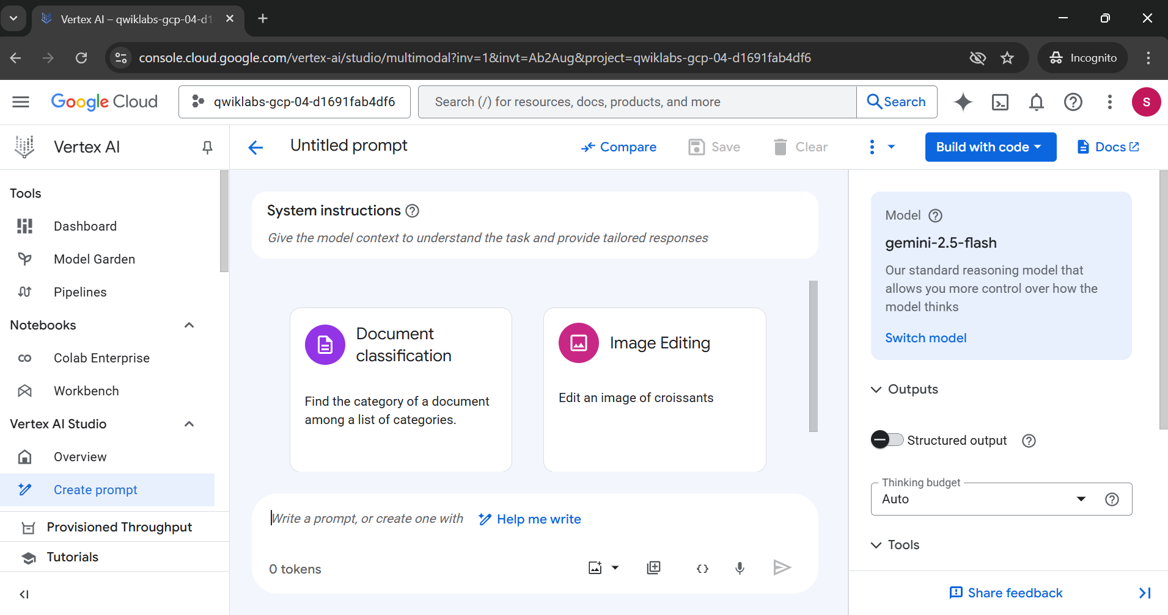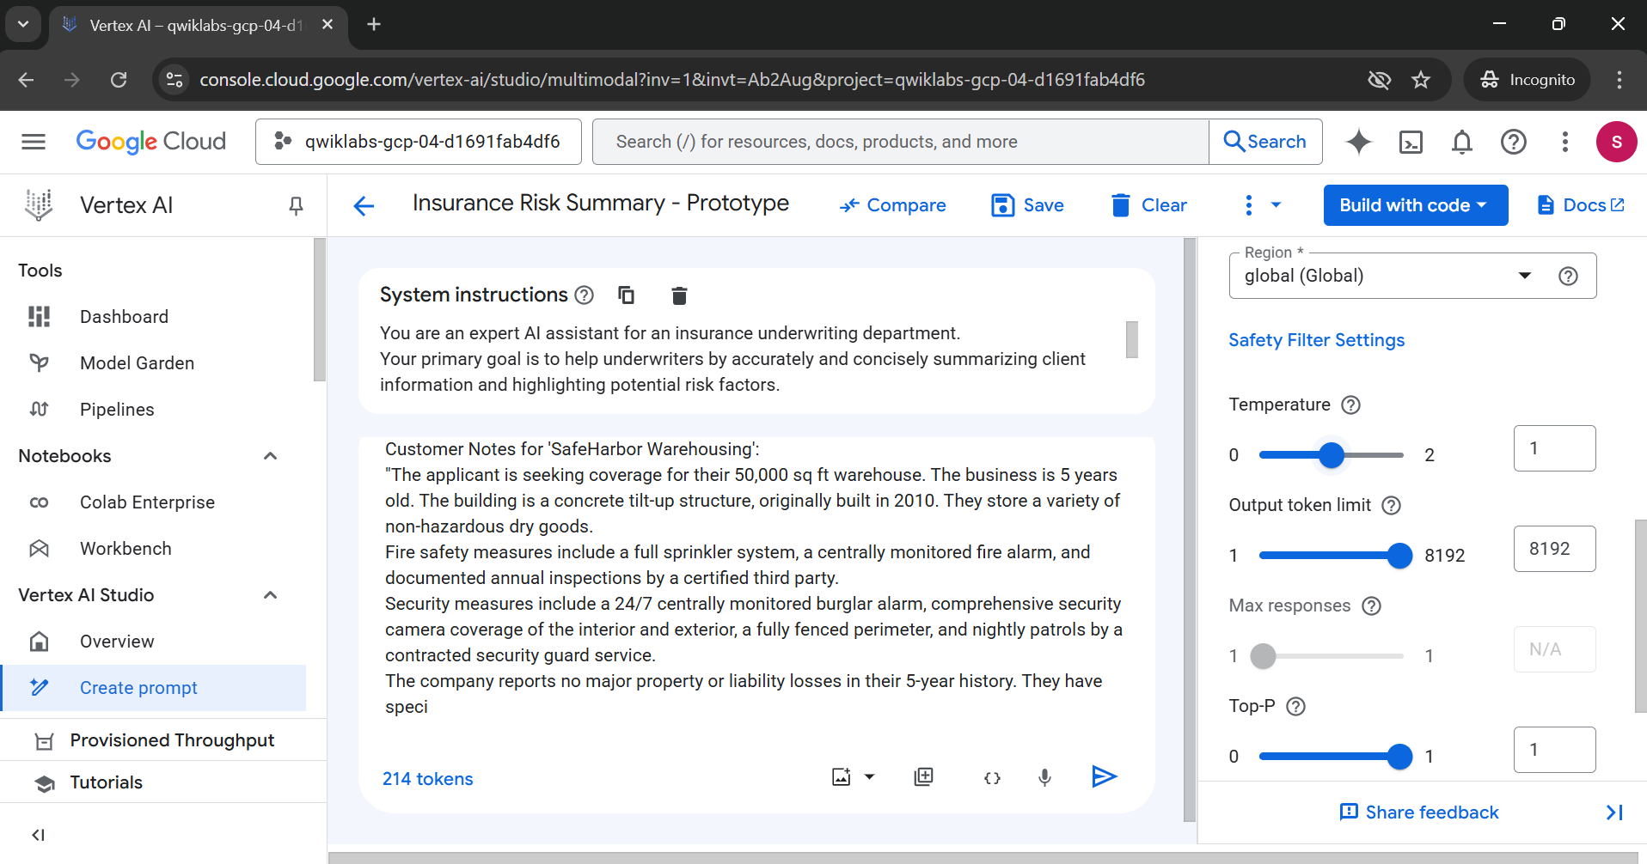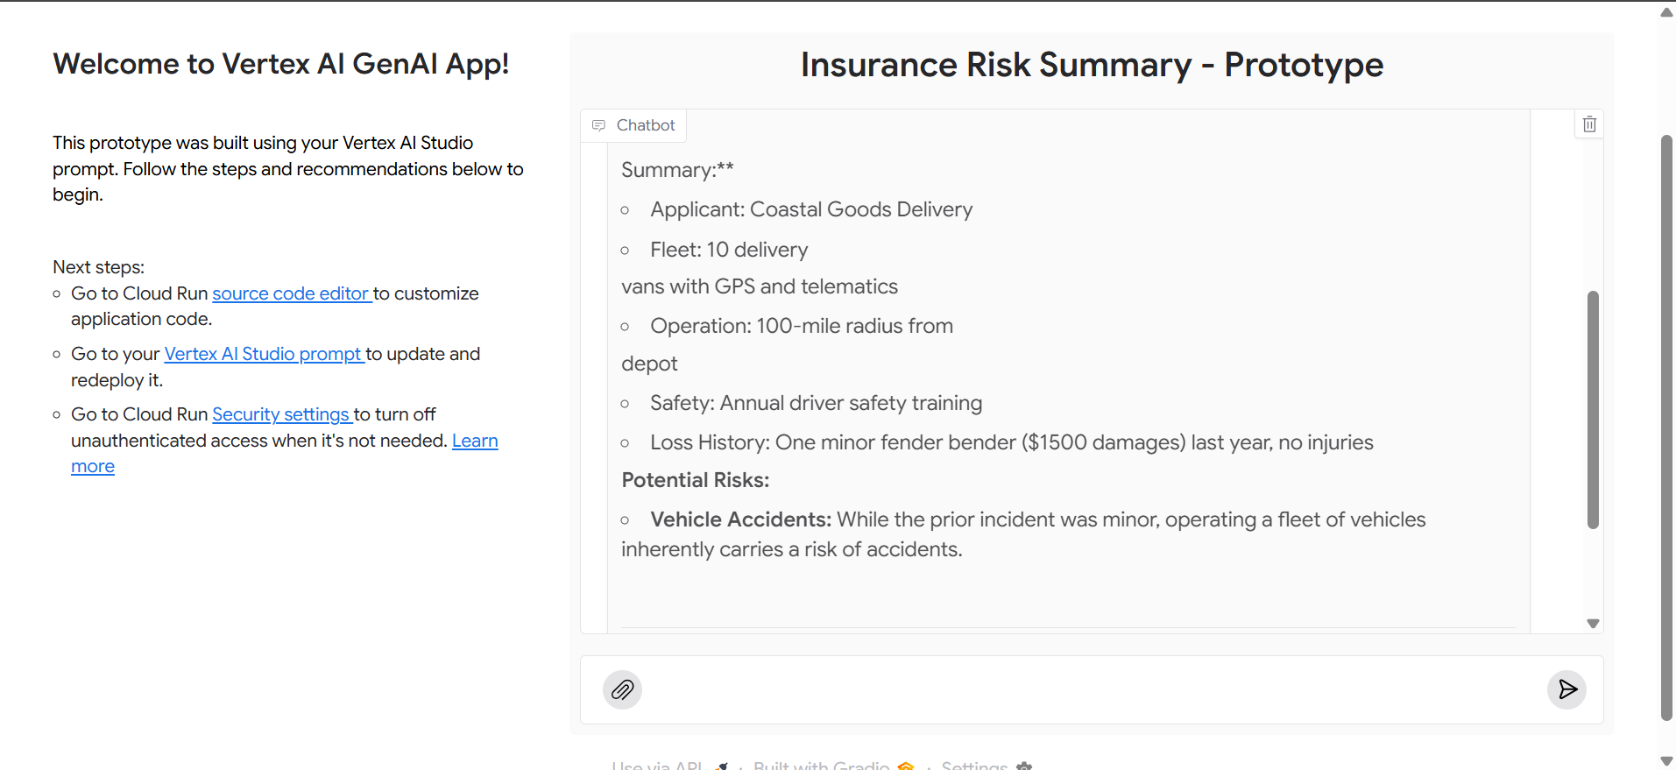

### Task 2 – Design effective prompts

We refined the initial prompt for better accuracy and control.  
We explored zero-shot prompting (no examples) and few-shot prompting (with examples)  
to improve information extraction and summarization quality.  
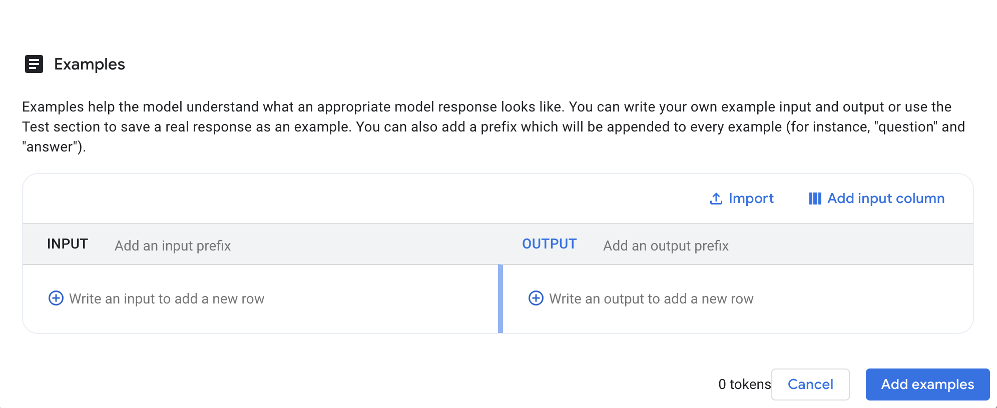

### Task 3 – Engineer and manage prompts

We tested different model parameters such as temperature to control output creativity and precision.  
We also used the Compare feature in Vertex AI Studio to analyze differences between prompt versions.  
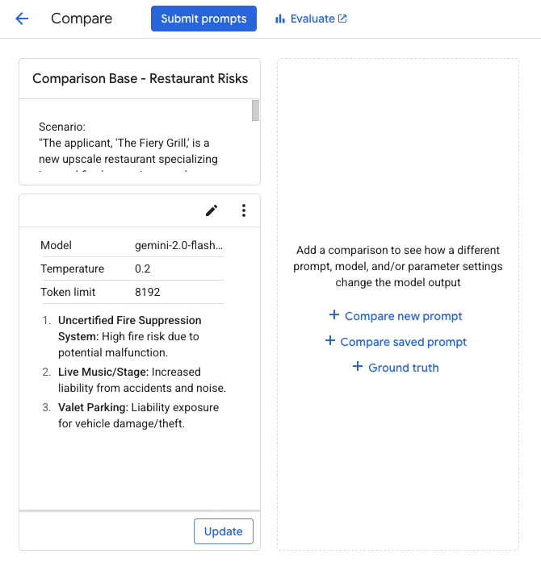

### Task 4 – Use multimodal prompts with Gemini

You worked with Gemini to analyze both text and image inputs.  
You created prompts to extract data or generate descriptions from images.  
This task showcased the power of multimodal generative AI.

### Task 5 – Explore Vertex AI Media Studio

You explored the media generation features of Vertex AI Studio.  
You generated various content types—images, videos, and voice—from text prompts.  
All media was created without coding, purely through prompt instructions.  
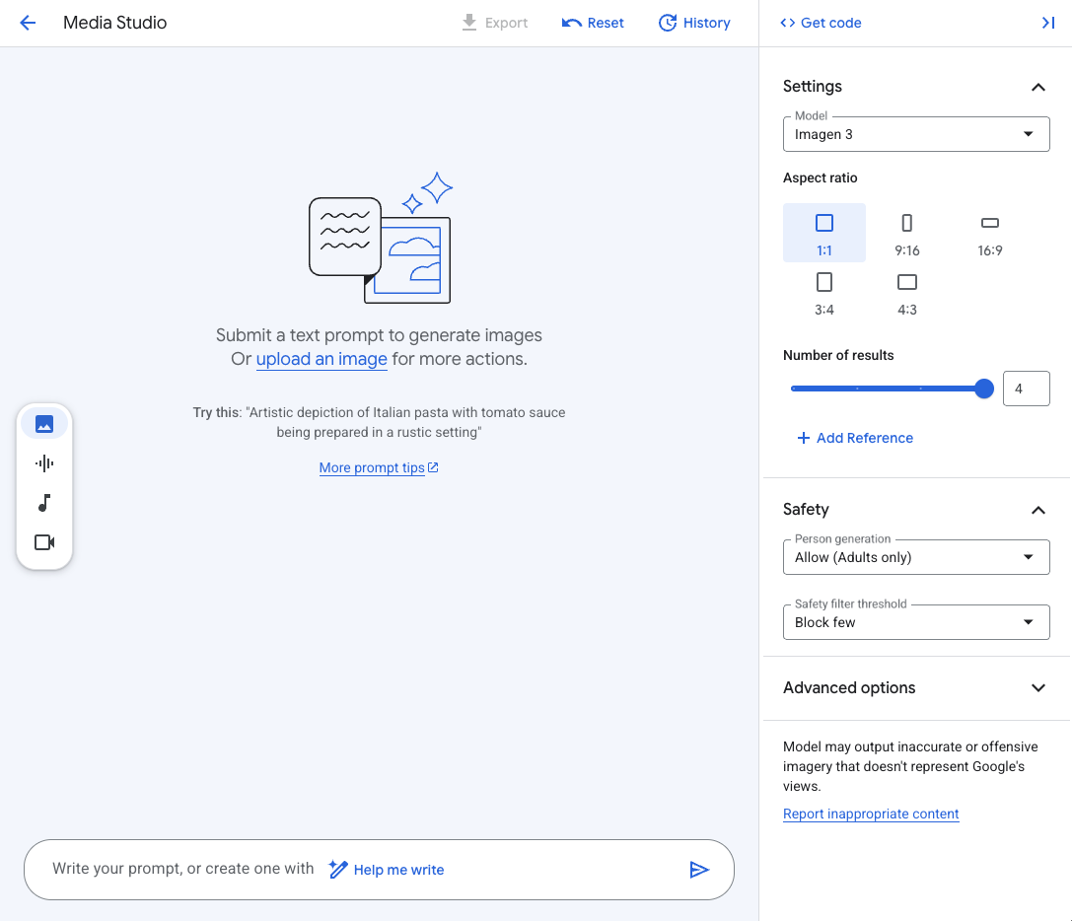

## What I Learned

- I learned how to build a functional AI application from a simple prompt idea using Vertex AI Studio.  
- I developed prompt engineering skills, including zero-shot and few-shot prompting techniques.  
- I explored how adjusting configuration settings like temperature affects model responses.  
- I gained hands-on experience with Gemini’s multimodal capabilities, combining text and image inputs.  
- I discovered how to generate media content—images, video, and voice—directly from prompts without coding.  
- Overall, the lab gave me practical insight into designing, managing, and deploying generative AI solutions in the cloud.